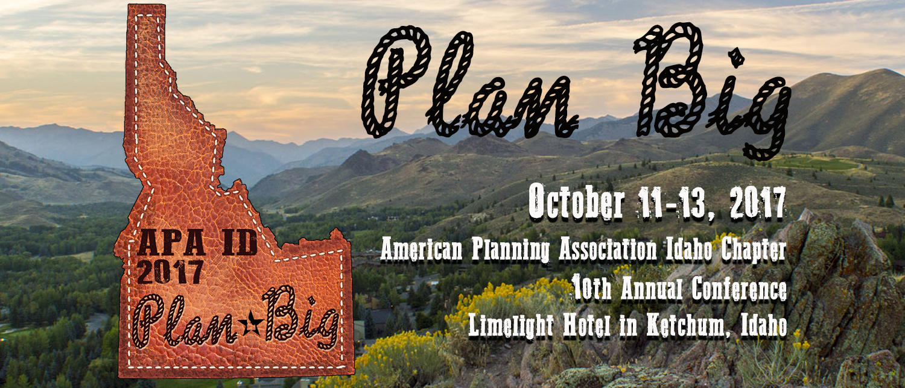

Call for Session Proposals!

Planners,

APA Idaho is excited to open this year’s “Call for Session Proposals” for our 10th Annual Conference, “Plan Big”, to be held in scenic Ketchum, Idaho! We invite you to take advantage of this opportunity to share your experiences and expertise as they relate to the conference theme.

We are seeking a broad range of session proposals that will appeal to planners in urban and rural areas. Proposals should reflect emerging best practices, dynamic ideas, and encourage discussion among presenters and audience members.

Session proposals are due no later than 5:00 PM Mountain Standard Time on Friday, July 21, 2017. Please complete the form below for each session you propose. The form is also available on APA Idaho’s website at http://www.idahoapa.org. All session proposals must be completed in MS Word format to facilitate APA Idaho’s preparation of future programs and applications for AICP certification maintenance credits. You will be notified no later than August 11, 2017 as to whether your session has been selected for the conference. If you have any limitations on your availability, please identify those in the form’s “Session Availability” section.

Please email the completed form to Charles Hutchinson at charles.hutchinson@powereng.com.

We look forward to seeing you in Ketchum – an APA Main Street Award winner!!

Session Information
Proposed Session Title:

Session Summary:

Session Format: Click on all appropriate boxes
☐ Presentation | ☐ Panel Discussion | ☐ Interactive Workshop
☐ Other (Explain):

Theme (Explain in Abstract below) | ☐ Data/Technology/Innovative Tools | ☐ Rural/Urban Edge
 | ☐ Public Involvement/Outreach | ☐ Small Towns Big Plans
 | ☐ Planning for an Aging Population | ☐ Community Development
 | ☐ Parks/Natural Resources Planning | ☐ Other/General Planning
Target Audience | ☐ All/General | ☐ Interdisciplinary
 | ☐ Student/New Professional/P&Z | ☐ Experienced Professional
Continuing Education | Will session be appropriate for continuing education credits?
 | ☐ YES – AICP CM credits | ☐ NO
Audio/Visual (A/V) Needs | ☐ Projector | ☐ Computer
 | ☐ Other A/V needs:
Session Duration:  Click one box only | ☐ Speed Session: 10-15 minutes/speaker with Q&A at the end  ☐ Standard Session: 75 minutes  ☐ Planning Law or Planning Ethics: 90 minutes  ☐ Deep Dive: 2 ½ hours, which will include a mobile tour or hands-on planning exercise
Notes

Contact Information
Name: |  | Title:
Organization:
Address:
Phone: | Email:
Your role in session: ☐ Panelist ☐ Moderator ☐ Organizer
Will you be registering for the conference? ☐ YES ☐ NO
Speaker Information
Speaker Name #1:
Title/Credentials/Organization:
Address:
Phone: | Email:
Speaker Name #2:
Title/Credentials/Organization:
Address:
Phone: | Email:
Speaker Name #3:
Title/Credentials/Organization:
Address:
Phone: | Email:
BEFORE AUGUST 1, 2017: Submit a Word document containing a one paragraph bio for each speaker, so they may be included in the Conference Program.
Additional Information
Session Abstract | Please attach a Word document (500-word limit) describing:  - How the session relates to the “Plan Big” theme.  - How the session meets a specific planning-related training objective.  - How the session will offer a professionally relevant learning experience for a planner with at least 4 years of experience.  - What you want the attendees to learn from this session.
Session Availability | Please list here any days/times you would be unable to present at the conference.
Speed Sessions | Speed sessions include 4 to 5 presenters in one session, each presenting on a related topic for 10-15 minutes with questions at the end. This format encourages problem-solving and collaboration, as well as networking around shared challenges. The APA Idaho Conference Committee will combine presenters into sessions.
Questions/Help
If you need additional information or need help completing this form, please contact Charles Hutchinson, AICP at charles.hutchinson@powereng.com or 208.788.0352.

